Step 1- Open cmd and type mongosh. Then type **use adit** this cmd is used to create a database. Then type **db.emp.insertOne({name:”priyanka”, city:”delhi”, age:22, salary:25000})** (Here insert cmd use to insert value into the collection).

Step 2- Into the adit database we insert 5 values.

1. Write a Mongodb Query to show the first two results of your documents.

Step 3- Type **db.emp.find().limit(2).**(here limit cmd use to show first 2 document)

Output:

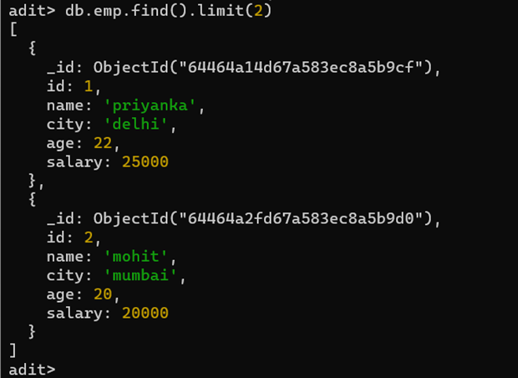

1. Write a Mongodb Query to retrieve the record of all employees where City is equal to Delhi.

Step 4- Type **db.emp.find({city:{$eq:”delhi”}})**.

Output:

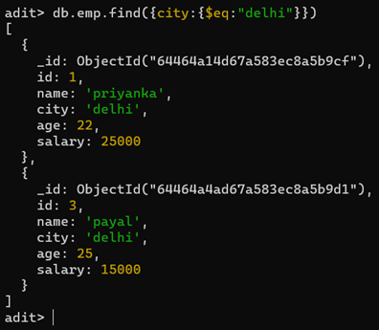

1. Write a Mongodb Query to retrieve the record of all Employees where the age of the employee is less than 23.

Step 5- Type **db.emp.find({age:{$lt:23}}).**

Output:

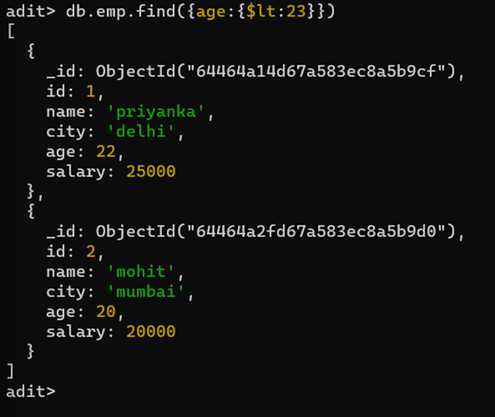

1. Write a Mongodb Query to retrieve the record of all Employees where the Salary of the employee is greater than 40000.

Step 6- Type **db.emp.find({salary:{$gt:40000}})**

Output:

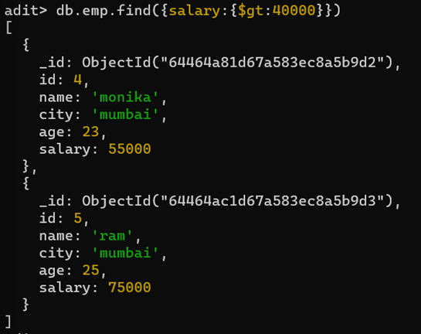

1. Write a Mongodb Query to retrieve the record of all employees where the City of the Employee is not equal to Delhi and the salary is greater than 45000.

Step 7- Type **db.emp.find({$and:[{city:{$ne:"delhi"}},{salary:{$gt:45000}}]})**

Output:

